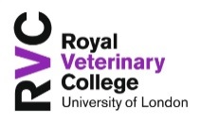

Postgraduate Course Representative Agreement 2015/16
We want you to enjoy your 12 months as a Course Representative and we are committed to providing a Student Rep System which enables you to be as effective as possible, with the best opportunity to act as the voice of your year group. To do this, we need to your help!

This document explains the responsibilities of a Course Representative, shows you the time commitment it is likely to involve and outlines what we will do to support you.

We ask that you read the agreement to acknowledge that you understand
your role as a Course Rep and our commitment to you.
Time in post
12 months
Your responsibilities as a Course Representative

- Attend Course Rep Induction Training
- Ensure that students you represent know who you are and how to contact you
- Be proactive in seeking your year groups views, concerns and suggestions.
- Be truly representative – it’s not just your opinion!
- Attend ‘Course Management Committee’ meetings (or send apologies and identify a deputy) and present student issues or provide student opinion on issues
- When appropriate, attend the ‘College Services Forum’ (or send apologies and identify a deputy) and present student issues or provide student opinion on issues
- Participate effectively – be positive, clear and refer to evidence
- Follow up and report back on actions assigned to you at the various meetings you will attend
- Feedback to your year group on the outcome of any issues raised
- Communicate with the SU Vice President for Representation and the SU Postgraduate Officer to share key issues and good practice
- Where possible, support a handover to new student reps

Course Rep Induction Training, October 2014

Yearly Time Commitment

- Course Rep Induction Training – 2.5 hours, Thursday 29 October 2015, 17:45-20:00, Camden
- Course Management Committees – 6 hours (1 meeting each term, around 2 hours per meeting)
- Skills training – 6 hours, Saturday 14 November 2015, Hawkshead (free training to help you as a student and a rep!)
- Rep Socials - 4 hours (2 socials per academic year, around 2 hours per social)
Course Reps should also spend time engaging in informal Representation duties which aid their knowledge of student feedback. This might include any activities to gather student feedback such as talking to students face to face or on social media.

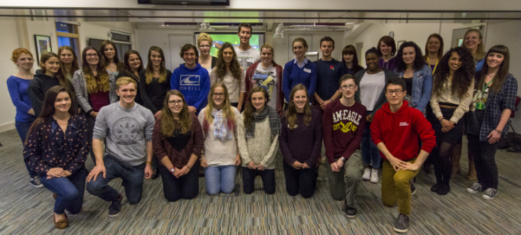
Skills Training, November 2014

What you can expect from us to support you in your role

- Pay attendance allowance of £20 for attending college ‘academic’ committee meetings
- Work with college colleagues to ensure your voice is heard
- Deliver a Training and Support Programme to help train you to effectively represent students and develop your skills
- Hold a minimum of 2 Rep Socials per academic year
- Hold a minimum of 1 Skills Training event per academic year
- Facilitate membership of student representatives on Colleges’ Academic Committees, providing opportunities to be involved in strategic committees such as the Teaching Quality Committee (TQC), Learning, Teaching, Assessment Committee (LTAC) and Student Development Committee (SDC)
- Work with you to ensure that the outcomes of feedback from students are reported back to them
- Liaise with university colleagues to ensure that additional opportunities for involvement in quality assurance activities are available to you
- Maintain a website for Student Rep information, feedback and paperwork

If you have any queries please contact either Maxine Bailey, Academic Quality Officer (mbailey@rvc.ac.uk) or Sam Hornsey, SU Vice President for Representation (surepcomms@rvc.ac.uk).

Approximate time commitment provided for general Course Rep duties only. Additional time commitments will apply if elected to other College committees

