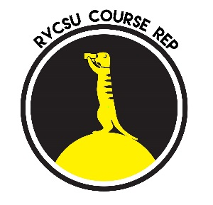RVCSU Postgraduate Course Rep Agreement 2020/21

‘Our course reps are student champions, delivering excellent representation for their peers’ [RVCSU Strategic Plan]

‘It was definitely rewarding to put forward people’s views
and genuinely help them with their university life’ [SU Course Rep]

We want you to enjoy your 12 months as Course Representative and are committed to supporting you in your role to be as effective as possible. To do this, we need to your help! This document explains the responsibilities of a Course Representative, shows you the time commitment it is likely to involve and outlines what we will do to support you. It is possible that some activities may be adapted in response to our changing circumstances.

We ask that you read the agreement to acknowledge that you understand your role as a Course Rep and our commitment to you.

Time in post
12 months

4 key responsibilities

- To represent your year groups views and be proactive in collecting their feedback.
- To act as a communication channel between staff and students.
- To improve students’ experiences by working with the College and as an active member of the SU.
- To keep your year group in the loop by reporting back on decisions and changes.

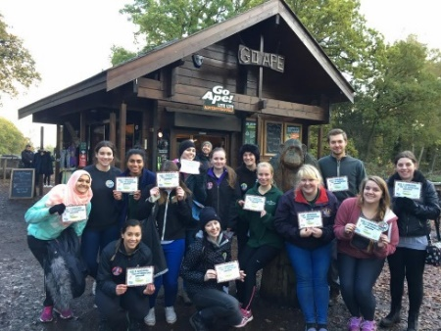
Time commitment
As well as the activities below Reps should spend time engaging in activities to gather student feedback and to discuss feedback with staff.

Activity | Timing | Approx time commitment
Reps Induction training programme | Tuesday 27 October 17:00-19:00 + multiple optional sessions | 2 hours mandatory session + multiple optional sessions
Course Management Committees | 1 meeting each term | 6 hours (2 hours per meeting)
Skills Training | Saturday early November, day event | 6 hours
‘Keep in touch’ fortnightly drop in sessions | Fortnightly drop in sessions | 1 hour fortnightly (optional)

What you can expect from us to support you in your role

- Pay a £20 attendance fee for attending college ‘academic’ committee meetings.
- During 2020/21 the SU will identify opportunities to provide Reps with awards and financial benefits.
- SU and College will work to ensure your voice is heard.
- Deliver a Training and Support Programme to help train you to represent students and develop your skills. This will include a minimum of Induction Training, 1 Skills Training event per academic year.
- Work with you to ensure that the outcomes of feedback from students are reported back to them.
- SU and College will ensure that additional opportunities for involvement in quality assurance activities are available to you.
- SU will maintain a website for Student Rep information, feedback and paperwork.

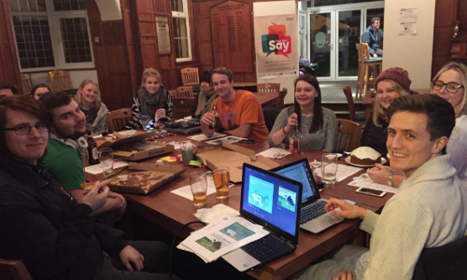

If you have any queries please contact either Georgia Buck, SU Vice President for Representation (surepcomms@rvc.ac.uk), Gareth Jones and Victoria Lindsay, SU Postgraduate Officers (supostgrad@rvc.ac.uk) or Maxine Bailey, Academic Quality Officer ‘Student Engagement’ (mbailey@rvc.ac.uk).

