Club and Society Charity Adoption form
This form is for the adoption of a charity by a club or Society.
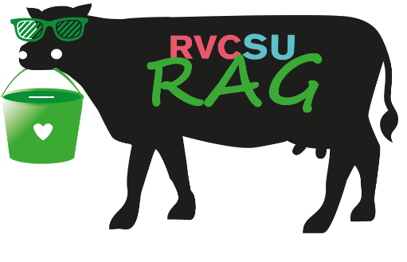

Name of club, society or student group
CLUB/SOC Email address
What Charity do you want to adopt and fundraise for?
The Uk charity number
(This can be found on Search the charity register - GOV.UK (www.gov.uk) ).
Over what period would you like to adopt this charity for

Please Email this form to surag@rvc.ac.uk

